**HTML Introduction**

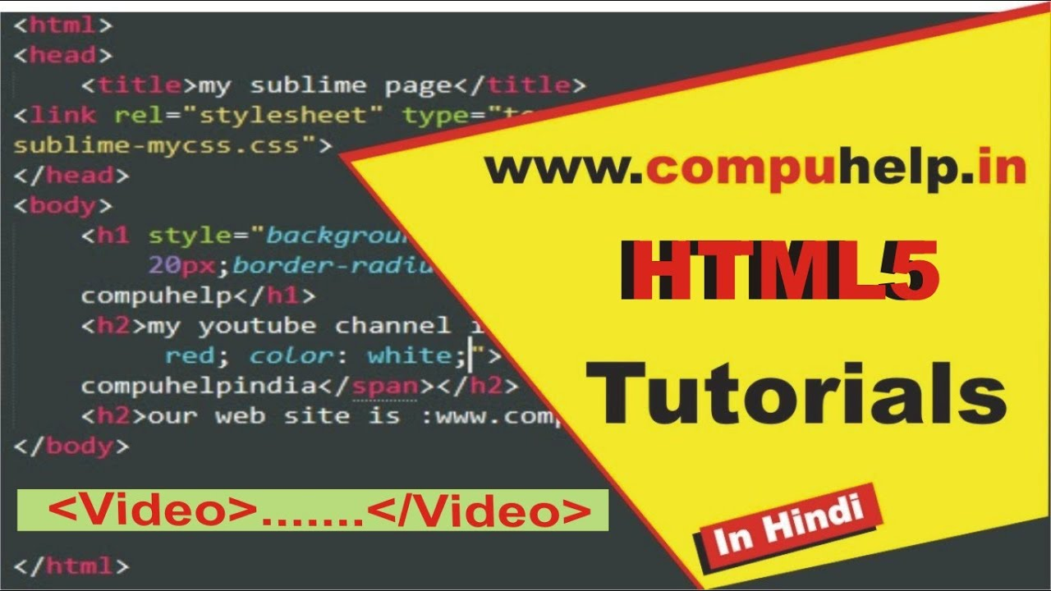

What is HTML?

* HTML stands for Hyper Text Markup Language, and it is a markup language for creating web pages.
* HTML is made up of elements that tell the browser how to display the content.
* HTML elements label content such as "this is a heading," "this is a paragraph," "this is a link," and so on.

## A Simple HTML Document

## <!DOCTYPE html> <html> <head> <title>Page Title</title> </head> <body> <h1>First Heading</h1> <p>first paragraph.</p> </body> </html>

### **Example Explained**

* The <html> element is the root element of an HTML page
* The <head> element contains meta information about the HTML page
* The <!DOCTYPE html> declaration specifies that this document is an HTML5 document
* The <body> element defines the document's body and is a container for all visible contents, such as headings, paragraphs, images, hyperlinks, tables, lists, and so on.
* A paragraph is defined by the <p> element.
* The <h1> element defines a large heading
* The <head> element contains meta information about the HTML page
* The <title> element specifies a title for the HTML page (which is shown in the browser's title bar or in the page's tab)

## What is an HTML Element?

An HTML element is defined by a start tag, some content, and an end tag:

<tagname>Content goes here...</tagname>

The HTML **element** is everything from the start tag to the end tag:

<h1>My First Heading</h1>

<p>My first paragraph.</p>

|  |  |  |
| --- | --- | --- |
| **Start tag** | **Element content** | **End tag** |
| <h1> | My First Heading | </h1> |
| <p> | My first paragraph. | </p> |
| <br> | *None* | *none* |

## **Note:** Some HTML elements, such as the <br> element, have no content. These are referred to as empty elements. There is no end tag on empty elements!

## Web Browsers

A web browser's job is to read HTML documents and display them correctly (Chrome, Edge, Firefox, Safari).

The HTML tags are not displayed by the browser; instead, they are used to determine how the document should be displayed:

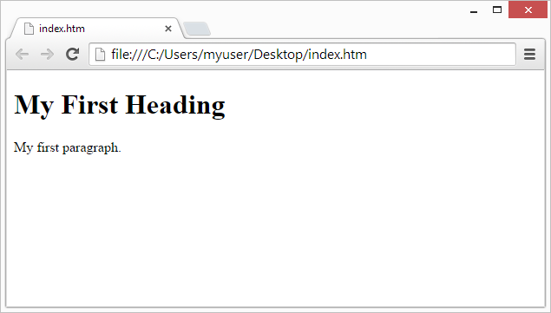

**HTML Page Structure**

Below is a visualization of an HTML page structure:

**Note:** In a browser, the content inside the <body> section (the white area above) will be displayed. The content of the <title> element will appear in the title bar of the browser or in the tab of the page.

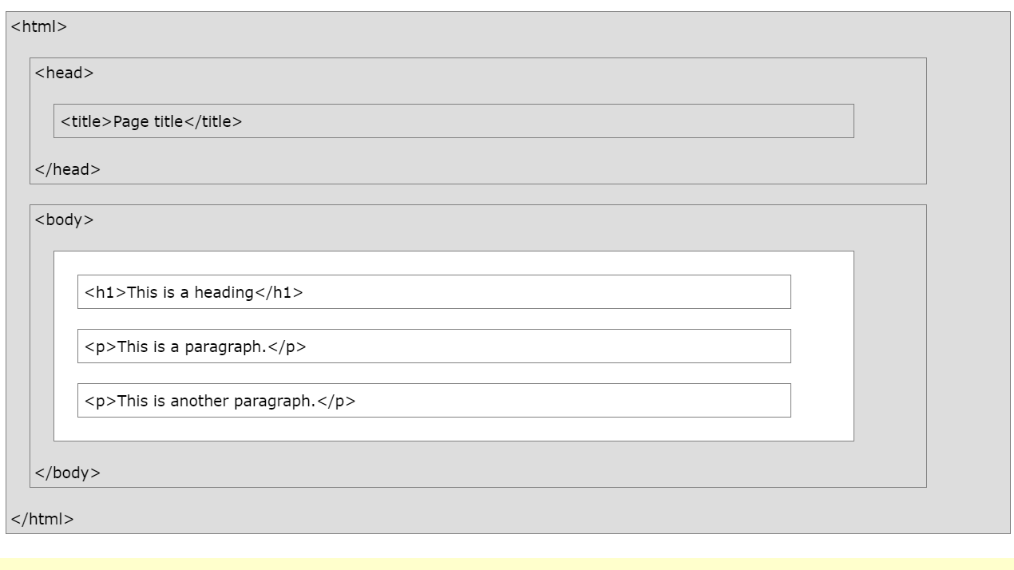

## HTML History

There have been many versions of HTML since the beginning of the World Wide Web:

|  |  |
| --- | --- |
| **Year** | **Version** |
| 1989 | Tim Berners-Lee invented www |
| 1991 | Tim Berners-Lee invented HTML |
| 1993 | Dave Raggett drafted HTML+ |
| 1995 | HTML Working Group defined HTML 2.0 |
| 1997 | W3C Recommendation: HTML 3.2 |
| 1999 | W3C Recommendation: HTML 4.01 |
| 2000 | W3C Recommendation: XHTML 1.0 |
| 2008 | WHATWG HTML5 First Public Draft |
| 2012 | [WHATWG HTML5 Living Standard](http://whatwg.org/html/) |
| 2014 | [W3C Recommendation: HTML5](http://www.w3.org/TR/html5/) |
| 2016 | W3C Candidate Recommendation: HTML 5.1 |
| 2017 | [W3C Recommendation: HTML5.1 2nd Edition](http://www.w3.org/TR/html51/) |
| 2017 | [W3C Recommendation: HTML5.2](http://www.w3.org/TR/html52/) |